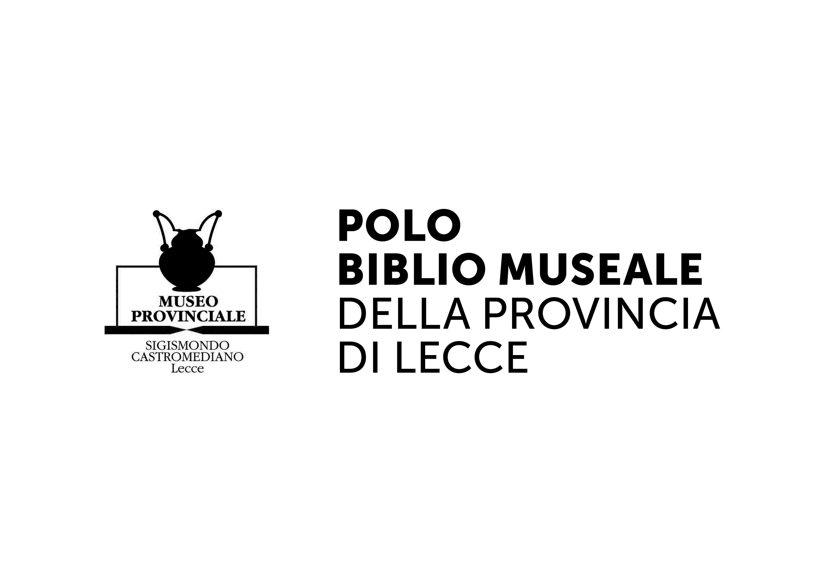
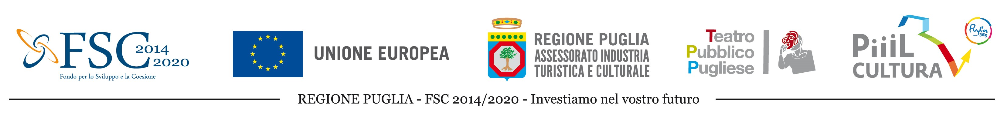
LANDXCAPES art, storytelling, landscape
Residency program in Puglia, October 8th - 19th, 2018
DEADLINE JULY 15th 2018, h. 8 pm (Italian time)
APPLICATION FORM

Name
Surname
Date of birth
Citizenship
City of Residency
Address
Country
Phone
Email
Website

Please choose one of the following discipline:

Performance
Storytelling
Design
Video / Photography
Public art / Land art
Visual art (Painting/Sculpture)

1. Requirements
- Artists between the ages of 18 and 35 can participate to this call.
- Group applications are not admitted, but only individual candidates.
- To check the list of countries for which the call is open, please visit the following website: http://www.bjcem.org/landxcapes/
- This call is also open to artists who have already participated in other BJCEM projects, as long as they meet the required requirements.
- Participation is free. No fee will be paid for participation.
2. Mandatory attachments
To participate to this call you must prepare the following documents, in English or Italian:
- This application form filled in all its parts
- CV
- Portfolio (max 6 MB)
- Motivational Letter (max. 1 page)
All the documents shall be sent to application@bjcem.org not later than July 15th 2018, h 8 pm (Italian time). Any application not complying with the requirements will be automatically rejected. Applying to the call implies full acceptance of the regulations indicated in the Call that can be found at the following link: http://www.bjcem.org/landxcapes/

Signature ………………………………… Date …………........…………........…...

FOR FURTHER INFORMATION
BJCEM Executive Office | info@bjcem.org | +39 011 19504733 | www.bjcem.org

-.-.-.-.-.-.-.-.-
The project "LandXcape art, storytelling, landscape" is supported by Puglia Region, in collaboration with Teatro Pubblico Pugliese and with BJCEM, to rely on the Development and Cohesion Fund 2014-2020, Pact for Puglia, Intervention Area IV “Tourism, culture and enhancement of natural resources”

