ESC Activity in Service RENFORTS

Themes: Disability, Social Inclusion and European awareness

Project period
ESC activity will start on 01/02/2020 for duration of 12 months

Looking for one volunteer on this activity but s/he will be part of a community of in total 7 ESC volunteers on project in the same town

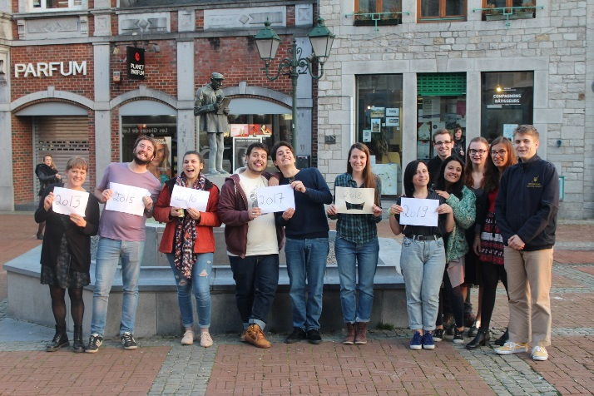

- ABOUT THE PROJECT

1.a. The Hosting Organisation

The service RENFORTS is a part of the non-profit association ANDAGE, created in order to improve the quality of life of people with mental disabilities and their families.

Renforts was born in 2007 and at the beginning, when the center opened, just three young adults with disabilities decided to try the chance. In 2009, they became 13 to believe in the project and to flourish thanks to various activities. Nowadays the service counts more or less 30 young users who are in between 18 and 40 years old.

Since end 2017, Renforts holds the title of “Service d’Accompagnement pour Adultes” (aka “SAC”) which means “Support Service for Adults”.

Our staff is made up of 7 workers working full time or part-time. We are also constantly supported by several local volunteers and we host very often students from the local schools who come at our place for their school internship.

The beneficiaries (adults with mental disabilities) of Renforts generally quite autonomous and independent adults but the service aims at encouraging their social inclusion by offering them to participate in social and collective activities and by providing them with personalized daily support starting from their personal needs, interests and wishes.

Renforts staff supports the beneficiaries following 3 axes:

- Individual support based on personal needs expressed by the people with mental disabilities. The wishes expressed by the beneficiaries can be very diversified. Examples: find an accommodation; discover the work in a field they are interested in; daily work in a local partner organization; learn new specific skills (IT; woodworking; gardening;…).
- Collective support ex: information sessions about health and sexuality;
- Community activities ex: gardening in the public park in partnership with the municipality.

With regard to making daily activities available for its public, Service Renforts runs 4 main branches of service:

- As the personal needs of the beneficiaries are sometimes of the professional type, Renforts works with many local partners (schools, restaurants, youth centers, the cultural center, the horse riding school, the local municipality…). In this frame, the beneficiaries can develop skills and be active regularly while helping out the associations on a voluntary basis. The partners respect and interact with them in order to integrate them in the local social life. The tasks done by our service users are concrete and adapted to the partners as well as to the beneficiaries.

- A residential service called “Les Cerisiers” where some of our youngsters live together developing their autonomy and independency;

- The “Alterboutique et son Comptoir”, a shop where people can go to exchange for free different things or just to have a bio drink. The little bar of the “Alterboutique” is completely managed by the beneficiaries of Renforts with the help of their educators. The aim is to foster their inclusion in the local community through citizen activities supported by Andage;

- A collective garden located “Le site du Monument”, in partnership with the municipality of Marche-en-Famenne, where the beneficiaries can maintain a flowerbed with aromatic herbs, bird nests, “insects’ hotel” or construct wooden facilities.

Web page: https://www.andage.be/nos-services/renforts/
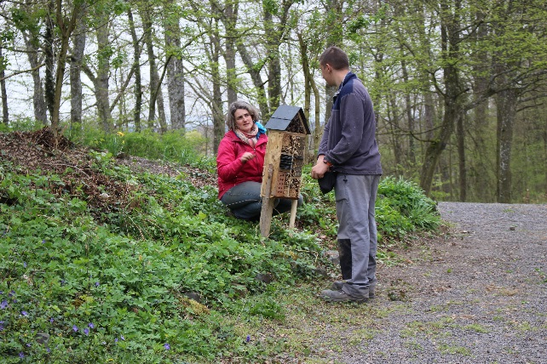
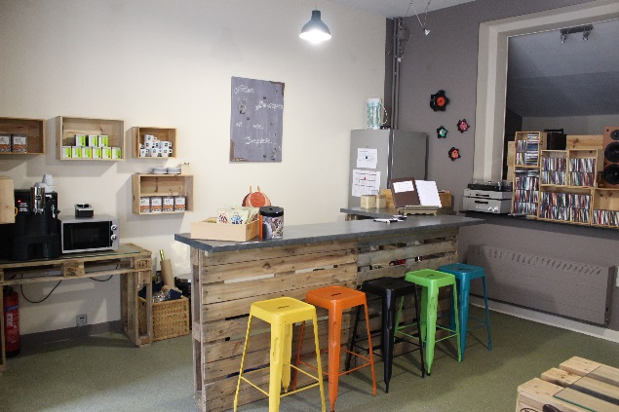

1.b. the volunteering tasks

We expect the ESC volunteer to take an active part into the staff work. S/he will support and accompany the young adults with disabilities during their daily activities. S/he will facilitate their investments in the tasks realization:

- Collective support: with the help of the staff, accompany the people with mental disabilities to their working place at partners’ or on collective activities, perform the tasks next to them (ex: gardening, little reparations, cleaning, serving the clients at the Alterboutique). During the first weeks, s/he will meet the different partners we work for and will be introduced to the several tasks. Then, according with the agenda of the staff and his/her preferences and skills, s/he will have the opportunity to choose the activities s/he’s more interested in.

- Individual support: listen to the personal needs of the beneficiaries and proceed to a personalized plan of action with the support of the educators. The volunteer is also a person who can support the beneficiaries in the process of assimilation of their learning outcomes and their daily progress. However, a distinction is made between educators and the volunteer: the volunteer will not be in charge of the whole educational plan but will support them in the concrete steps within the process. In a second phase of the project, when the volunteer is acquainted with the beneficiaries, he/she can offer them to help them out in the management of their accommodation (ex: test new cooking recipes, do the shopping, furnishing, DIY,…);

With the support of other workers, the volunteer will play a big role in the maintenance of a good relationship with the different partners, the beneficiaries and the staff of Service Renforts. The volunteer is a point of contact, someone who has more time to give in order to open a space of discussion for the beneficiaries with the aim of creating a social link.

The volunteer’s activities can be adapted according to his/her skills and interests. There is a space for personal projects to be implemented and s/he will surely have the support of the team. It is expected from the volunteer to suggest some ideas in order to improve the Service Renforts, having the will to evolve constantly. No matter which activities the volunteer will prefer, her/his ESC will always foresee very varied tasks! The volunteer will also have the opportunity to participate in other activities out of the Service Renforts but linked with the same target group such as board games evenings, movie nights organized by the Association des Compagnons Bâtisseurs or in various activities organized by the local youth center, both situated very close from volunteer’s accommodation and Service Renforts office.

1.c. Practical arrangements

Possible schedule:

Monday:
Between 08:30 and 09:00 welcoming of the beneficiaries in Service Renforts
09:15 cooking at the local school of St. Julie school (partner)
12:00-13:00 Lunch time
13:20-15:40 wrapping cutlery at the local hospital (partner)

Tuesday:

Between 08:30 and 09:00 welcoming of the beneficiaries in Service Renforts
09:15-12:00 cleaning stables in the local horses’ stables place (partner)
12:00-13:00 Lunch time
13:20-15:40 several tasks at the youth local center (labeling, painting, cleaning, tidying up…)

Wednesday:
Between 08:30 and 09:00 welcoming of the beneficiaries in Service Renforts
09:15-12:00 Cooking workshop
12:00-13:00 Lunch time
14:30 Space for personal projects

Thursday:
Between 08:30 and 09:00 welcoming of the beneficiaries in Service Renforts
09:15-12:00 gardening at Renforts
12:00-13:00 Lunch time
13:20-15:45 Support in “Alter boutique” AND/OR team meeting

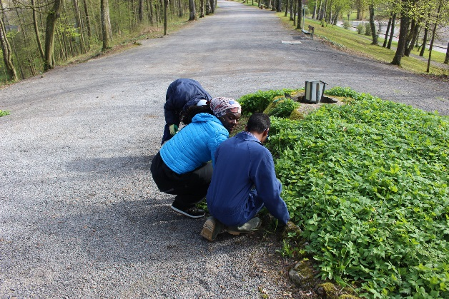
Friday:
Between 08:30 and 09:00 welcoming of the beneficiaries in Service Renforts
09:15-12:00 Gardening at the eco-village “La Gatte d’Or”
12:00-13:00 Lunch time
13:20-15:45 Gardening at the eco-village “La Gatte d’Or”

This timetable will be changed in order to integrate the French lessons and the volunteer’s interests.

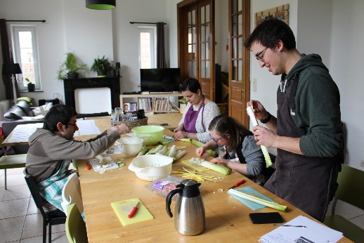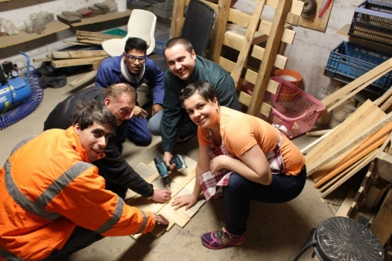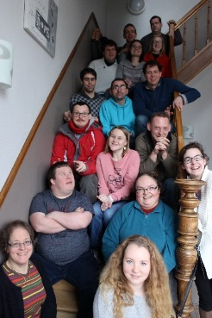

Five days per week will be worked on average/ Days off will compensate the extra shift hours if necessary to keep an average of 35 hours a week.
Accommodation: The volunteer will be hosted in a house that s/he will share with other people. The house will be located in the centre of Marche-en-Famenne and will have all the modern facilities.
Language course: OLS + French lesson: an online language course is provided as part of the project support from the Commission allocated on the basis of a level test to complete before the activity starts. The volunteer is also encouraged to join free French lessons given in the municipality or around.
Insurance: all participants in cross-border activities have to be covered, throughout the activity period, by the obligatory European Solidarity Corps insurance plan set up by the European Commission. This coverage is only complementary to the mandatory coverage of the European Health Insurance Card (EHIC), which must be obtained prior to departure.
In certain cases, when national rules deprive participants from coverage under EHIC for the duration of the placement, CIGNA will provide full coverage. However, participants must provide proof that obtaining the EHIC in their case was not possible and they should contact their National Agency in order to seek tailored advice, for their specific circumstance.
The participant must read carefully the insurance-related information found online here: https://www.cignahealthbenefits.com/en/plan-members.
Food: the volunteer will receive a budget and will take care of the meals by her/himself.
Participation in the European Solidarity Corps is free of charge for the participant, except for exceptional contribution to travel costs. The volunteer will receive free board and lodging during the whole activity. In addition, s/he will receive a small allowance (pocket money) for personal expenses throughout the duration of the activity, including holiday.

- ABOUT THE PROJECT ENVIRONMENT

2.a. Location of the project
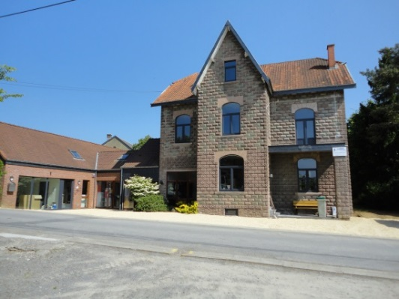
The office of Service Renforts is located close to the centre of Marche-en-Famenne. It’s here that the volunteer will welcome every morning the beneficiaries and the staff. In the building there is a kitchen, a living room, a computer space, a locker room and the dining room where the volunteer will eat together with the staff when not on activity outside. A big garden behind the house is also maintained by the staff and the beneficiaries.

The volunteer will live close from where s/he works, in Marche-en-Famenne, a small town situated in the south French speaking part of Belgium. With about 17 000 Inhabitants, the municipality of Marche counts numerous villages: Hollogne, Waha, Verdenne, Champlon-Famenne, Grimbiémont, Lignières, Roy, On.

The volunteer will be in daily contact with other ESC volunteers being hosted in other projects in the municipality.

Even if Marche-en-Famenne offers all the modern facilities, it is IMPORTANT to know that the town is situated in a semi-rural area and the nightlife here is less vivid than in bigger towns. Nevertheless, Liège, Namur or Brussels are not far from Marche which has good train connection.

2.b. The support organization: Association of Compagnons Bâtisseurs asbl

Renforts has welcomed EVS/ESC 7 times already with the support of the Association des Compagnons Bâtisseurs, aka CBB also located in Marche-en-Famenne where 6 other ESC volunteers are on project in different associations. CBB is a non-profit, non-political youth organisation recognized and financially supported by the Wallonia-Brussels Federation. The organisation proposes different kinds of activities, based on volunteering and non-formal education: local and international workcamps, medium and long term voluntary services (including ESC), and leisure time activities for and with disabled people, campleaders trainings…CBB is active within the different European Programmes of volunteering and non-formal education since 1997 and also hosts ESC volunteers each year. CBB’s role as support organization is to:
-Promote the project and link between local and the international networks;
-Support in the selection and preparation of European volunteers before arrival;
-Manage of administrative matters: budget allowances; support in the creation of the bank account and enrollment at the municipality; enrollment in insurance (if not done by sending organization);
-preparation of activity agreement;
-Provide pedagogical support for the volunteer and the hosting organization: ensures the participation to the NA seminars; organization of auto-evaluation meetings for the volunteer and the hosting organization to reflect on learning outcomes;
-Handle practical arrangements: accommodation; information about health insurance system in Belgium; indications about French lesson possibilities; online language tool;…
-create networking between all ESC volunteers of the hosting organizations we support.

- REQUIREMENTS AND APPLICATION PROCESS

3.a. Profile of the volunteer

- Age requirement to take part in ESC programme: 18-30 years old
- Prior to departure, the volunteer should be in contact with a support (sending) organization in order to receive information and preparation. Look up for a support organization in your region via this link: https://europa.eu/youth/volunteering/organisations_en
- Our project is open to anybody motivated by volunteering and who wishes to be involved in our organization and working in the field of youth work, regardless to their nationality, religion, believes, diploma, professional experience;
- The volunteer will have to provide a certificate of good conduct (CGC) related with the work with disabled people;
- It is advised that the volunteer has some basic knowledge of FRENCH or a strong motivation to learn it as the beneficiaries do not speak foreign languages;
- Thanks to this volunteering experience, the volunteer can really expect to acquire or improve many different skills (communication, adaptation, plan making, organization, French, interpersonal and social skills), to be part of a very friendly team and to be part of a local as well as international communities. In parallel, we think that to get the most of this project, the volunteer is expected to be:

-At ease with people;
-Patient and calm;
-Ready to build an atmosphere of confidence and safety with the public;
-Ready to involve him/herself in the several tasks we do with them;
-Able to work in team;
-Interested in the topic of people with mental disabilities;
-In tune with our philosophy of equality and openness to the difference;
-Willing to listen, communicate and care about adults with disabilities.

Testimony from Fanny, educator in Service Renforts and tutor of the volunteers

« I’ve been educator in Service Renforts for 8 years. I have a training as a school teacher and I would never have thought to work with people with mental disabilities before discovering this public in the frame of my previous job as animator in a Youth House. I realized these persons are in need of support but the relationships really create a mutual learning and a lot of happiness. I discovered benevolent, honest, joyful, smiling personalities who always make the most of every moment. Now I can state loud and clear that my work makes sense….” Fanny

3.b. How to apply

In the frame of the new program of the European Commission, the European Solidarity Corps, you first need to create a profile on the new data base: https://europa.eu/youth/solidarity_en (“JOIN THE CORPS”). Then, find the project and click on “apply”. It will send us a contact request.

Send the following documents written in FRENCH or ENGLISH to Morgane and Sophie (evs@compagnonsbatisseurs.be) until 23rd September 11h59 (brussels time).

-A specific motivation letter
-A CV
-The filled questionnaire (see from page here below of this document)

The application of those who will send their motivation letter and CV later than this date won’t be taken into consideration.
The pre-selected candidates will be contacted beginning of October for a skype meeting.

Contacts
Name | Morgane HAZARD (animator) and Sophie CHIELENS (coordinator)
Organisation | Association des Compagnons Bâtisseurs asbl
Address | 9 Place du Roi Albert Marche-en-Famenne 6900 Belgique
E-mail | evs@compagnonsbatisseurs.be | Internet | http://www.compagnonsbatisseurs.be/en/evs-with-cbb/
Telephone | +32 84 31 44 13 | Fax | +32 84 31 65 20

European Solidarity Corps volunteering activity with
« Service RENFORTS »
Marche-en-Famenne
To be filled electronically in and sent by email together with your motivation letter and CV to evs@compagnonsbatisseurs.be
BEFORE 23RD OCTOBER
Personal data :
By filling the information below, you provide us with personal information. You are aware of the fact and agree that the pieces of information will be used in the frame of the call for candidates for the Erasmus+ volunteering project. Your personal data will be used by the persons in charge of the selection of volunteers in the sending and coordinating/hosting organizations. Each part mentioned takes the responsibility of erasing the documents containing your personal data once the selection procedure is over.

Name and surname
Birthdate
Current address
Phone number
Email address
Availability period for the project
(preference will be given to the volunteers able to join the project from beginning of February 2019 for 12 months)

Have you ever taken part in a volunteering project under ERASMUS+?
!!!VERY IMPORTANT!!!
Sending organization
(Name, Accreditation or PIC number, post address, phone number, contact person’s name and email address)

What are your (long term) travel experiences?
ESC PASS REFERENCE NUMBER

Fill in this questionnaire in FRENCH or in ENGLISH

- According to you what is the role of a service as “Service Renforts”?

- What are your motivation to take part in this project?

- How do you see your role, as volunteer, within these activities?

- Which are your qualities and weaknesses for this project?

- Do you think you will be confronted with some difficulties? If yes, which ones? If no, why?

- Do you have some special practical skills you would want to share during your project?

- Do you feel at ease with people with mental disabilities?

- Case 1: In the first days of the project, if a beneficiary is asking you something but you do not understand because of his difficulties to express himself added to the linguistic barrier, what would you do?

- Case 2: A beneficiary shares a personal request to you: s/he would like to experiment having a lunch out with another person with mental disabilities. How are you going to manage it?

- What would like to know about our organization and activities? Do you have any questions before to accept to be volunteer in our project?

- What do you like to do in your free time? What do you think about living in a semi-rural town?

THANK YOU VERY MUCH FOR HAVING FILLED THIS QUESTIONNAIRE IN
WE WILL CONTACT YOU AFTER THE DEADLINE TO GIVE YOU OUR FEEDBACK!

In case of any doubt, do not hesitate to email us

For CBB,
Coordinating and hosting organization

Morgane HAZARD & Sophie CHIELENS
evs@compagnonsbatisseurs.be

