AMO-MICADOS

Theme 1: Early School Leaving / combating failure in education
Theme 2: Access for disadvantaged

Project period

ESC activity will start on 01/02/2020 until the 31/01/2021

- ABOUT THE PROJECT

1.a. The hosting organization
Micados is an AMO-“aide en milieu ouvert”: a prevention service with an open scope of intervention, which means we can be active on the streets or anywhere else.
Our public is made up by children and youngsters (0-22) and our mission is helping them to keep a balanced relation with their social, family and education backgrounds.
We work with and for youngsters to improve their skills in order to foster their autonomy and social emancipation.
Equality of opportunities and equal access to services are values we stand for in our daily activities.
Micados is recognized and financed by the Belgian Youth social service of Wallonia-Brussels federation. We are based in Marche-en-Famenne and we work in Marche-en-Famenne administrative district which is made-up by 8 rural or mid-rural municipalities (Marche, Hotton, Erezée, La Roche, Barvaux, Nassogne, Tenneville and Durbuy).
We have two branch offices: in La Roche and Barvaux.

Our action is based on two main working axes:

Individual support
A social and educational service based upon a listening, accompanying, orientation, support and mediation work, whose aim is to foster youngsters thriving in their family, scholar and social environment.
We intervene up to a youngster or his/her family’s request, always respecting youth social service moral code. The youngster can decide to stop asking our support at any time.

Community action
The objective of the community actions is to improve youngsters’ environment and to bring a global answer to individual problems and to the individual social demand.
We work to develop a local dynamic network: many initiatives are taken and projects implemented as a response to the needs expressed by individuals and families or as a consequence of our field analysis.

We work with youngsters around different themes:

- How to deal with addictions (for example to drugs…);
- Schooling and school dropout (since several year now we are implementing a project called “Sac Ados”: a civic gap year, whose aim is to support youngsters who left school and to encourage them to try to find again their place in the official education system or to start a professional training);
- Parenthood, and relations with parents;
- Leisure activities, always entailing reflection moments (work-camps, sport activities…);
- Self-esteem and youth representation.

Our ESC volunteer will especially take part in the “«Sac Ados» project”, devoted to youngsters’ orientation. At the same time our ESC volunteer will also take part in other collective and community projects Micados is active in.

1.b. The volunteering tasks

- The “Sac Ados” project
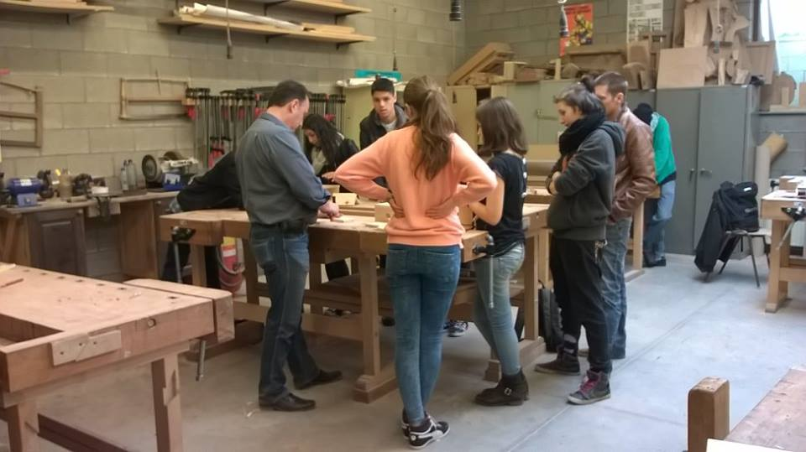
Our ESC volunteer will have as main mission to be involved in the project “«Sac Ados»”.
The aim of this project is to allow youngsters between 15 and 22 years old in school dropout situation, to have a reflection period about their future by taking part in manual works, creative activities and social actions which are useful to all our community (environment activities, building and painting activities, open space maintenance activities, activities for elder people, children or refugees, building music instruments for developing countries…).
By taking part in these activities, these youngsters have the opportunity to reflect about their future (go back to school, starting a professional training…).
«Sac Ados» activities will take place next to our local partners which are based not only in Marche-en-Famenne but also in villages around (a local rest home for elderly people, the asylum seekers center of Melreux, the environmental education center Natagora, Music Fund, Accueil Famenne…). Our aim is that these youngsters will develop personal and social know-how as punctuality, ability to take responsibilities, solidarity, social commitment, better self-esteem and ability to live in a group.

Under the frame of the «Sac Ados» project:
- From February until June - the volunteer will take part in the activities for the youngsters participating in «Sac Ados» program;
- From July until October- the volunteer will take part in the evaluation of the project to understand what to change for the next edition (finding new partners, preparation of workshops, accompanying the youngsters having participated in the project in their future personal initiatives…). Additionally, s/he will take part to other activities of Micados, essentially summer camps,
- From October until January - the volunteer will contribute to implement the activities of «Sac Ados» project for the next edition and next ESC volunteer.
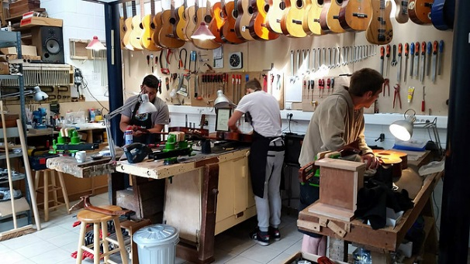
The volunteer will always work with the educator of MICADOS who is in charge of the «Sac Ados» project (s/he will also be always followed-up by another educator of MICADOS as his/her tutor). Thanks to this, the volunteer will have the opportunity to develop skills of accompanying youngsters, listening to them, supporting them, orienting them…
The volunteer will also develop practical skills (gardening, building, painting…).

- According to his/her skills and interests the volunteer will have the possibility to propose other activities and to implement a personal project.

- Other activities
The volunteer will also be involved in other activities proposed in MICADOS which mainly concern children and youngsters animation (for example children animation during the summer camps we organize). S/he will also take part in our weekly team meetings and will help us in some administrative task at the office.

1.c. Collective activities with other ESC volunteers
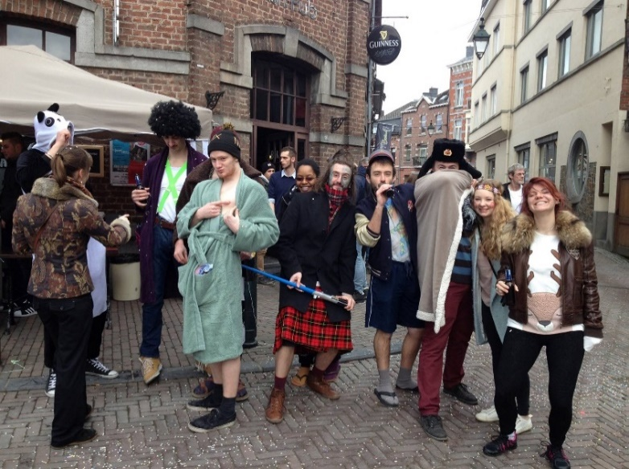
The European Solidary Corps volunteering activities within Compagnons Bâtisseurs is part of an ESC group project that aims to increase European awareness among youth in the town of Marche-en-Famenne and to maintain a close collaboration among the local youth services. For that reason, some activities will be run with other ESC volunteers (hosted by other local youth organizations). The volunteers will work together especially during special events organized once a year in Marche-en-Famenne: intergenerational events, youth services opening day…. The volunteers will help to prepare and follow-up these events. In some occasions, they could hold an information stand presenting ESC program and youth exchange opportunities. They could organize a “European night” in the local youth house and to present therefore their country and traditions.

1.d. Practical arrangements

Working days will be mostly during the week. During the “Sac-Ados” projects, you will work 4 days/week from 8:00 until 16:00. You will work during 5 days/week when the projects are not running.
Five days per week will be worked on average/ Days off will compensate the extra shift hours if necessary to keep an average of 35 hours a week.

Accommodation: The volunteer will be hosted in a house that s/he will share with other people. The house will be located in the centre of Marche-en-Famenne and will have all the modern facilities. The volunteer will receive a monthly allowance and will take care of the meals by herself/himself.

Language course: OLS + French lesson: an online language course is provided as part of the project support from the Commission allocated on the basis of a level test to complete before the activity starts. The volunteer is also encouraged to join free French lessons given in the municipality or around.

Food: the volunteer will receive a budget and will take care of the meals by her/himself.

Participation in the European Solidarity Corps is free of charge for the participant, except for exceptional contribution to travel costs. The volunteer will receive free board and lodging during the whole activity. In addition, s/he will receive a small allowance (pocket money) for personal expenses throughout the duration of the activity, including holiday.

- ABOUT THE PROJECT ENVIRONMENT

2.a. Location of the project

The AMO-Micados is located in Marche-en-Famenne, a 17 000 inhabitants town of the province of the Belgian Luxembourg. This unique situation will allow the volunteer to share the semi-rural life style of the area, but also to meet young people coming from different realities and horizons.
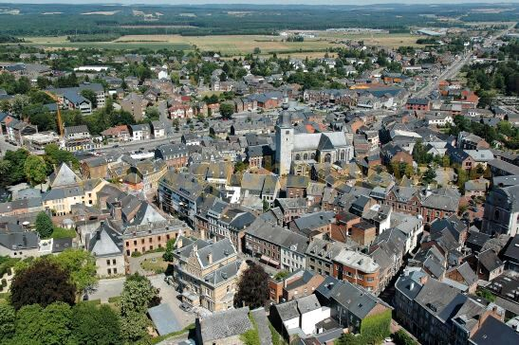
During his/her ESC volunteering activity, the volunteer will live and mostly work in Marche-en-Famenne.
The town offers all modern facilities (shops, supermarkets, sport center, cinema….).
For the urban-life-style-lovers, it is however IMPORTANT to note that our town is located in a semi-rural area. Even if it is not far away from the biggest Belgian cities (57 km from Liège, 106 km from Brussels, 47 km from Namur) and well connected by train, Marche-en-Famenne can sometimes look remote and very quiet.
The volunteer will be in contact with other ESC volunteers being hosted in other projects in the municipality.

2.b. The support organization: Association of Compagnons Bâtisseurs asbl
The hosting organization is supported by the Association des Compagnons Bâtisseurs, aka CBB located in Marche-en-Famenne in the south of Belgium. CBB is a non-profit, non-political youth organisation recognized and financially supported by the Wallonia-Brussels Federation. The organisation proposes different kinds of activities, based on volunteering and non-formal education: local and international workcamps, medium and long term voluntary services (including ESC), and leisure time activities for and with disabled people, campleaders trainings…CBB is active within the different European Programmes of volunteering and non-formal education since 1997 and also hosts ESC volunteers each year.
CBB’s role as support organization is to:
- Promote of the project and link between local and the international networks;
- Support in the selection and preparation of European volunteers before arrival;
- Manage of administrative matters: budget allowances; support in the creation of the bank account and enrollment at the municipality; enrollment in insurance (if not done by sending organization); preparation of activity agreement;
- Provide pedagogical support for the volunteer and the hosting organization: ensures the participation to the NA seminars; organization of auto-evaluation meetings for the volunteer and the hosting organization to reflect on learning outcomes;
- Handle practical arrangements: information about health insurance system in Belgium; indications about French lesson possibilities; online language tool…
- Create networking between all ESC volunteers of the hosting organizations we support.

3. REQUIREMENTS AND APPLICATION PROCESS

3.a. Profile of the volunteer

- Age requirement to take part in ESC programme: 18-30 years old
- Prior to departure, the volunteer should be in contact with a support (sending) organization in order to receive information and preparation. Look up for a support organization in your region via this link: https://europa.eu/youth/volunteering/organisations_en
- Our project is open to anybody motivated by volunteering and who wishes to be involved in our organization and working with children and youngsters regardless to their nationality, religion, believes, diploma, professional experience.
- We expect the volunteer to be very motivated to join the activity; to be open-minded and pro-active. We would appreciate that the volunteer shares with us the values of active citizenship, cultural openness, pluralism…
- We would prefer that our ESC volunteer is at least 22 years old, as s/he will mainly work (mainly but not only ) under the frame of our «Sac Ados» project and the youngsters who benefit from this program are in between 15 and 22 years old.
- Because the majority of the youngsters attending MICADOS activities don’t speak any other language than French, the volunteer must have good skills in French before starting the service.
- Because of the profile of the youngsters we work with, our volunteer must be an open minded person and ready to work with people coming from different social backgrounds.
- We expect the volunteer to build an atmosphere of confidence with the youngsters; be ready to involve him/herself in the several tasks we do with them (practical and artistic skills are welcome!); be able to work together with the staff; be interested in social inclusion and youngsters’ support and be ready to bring new ideas, new energy and enthusiasm!
- The volunteer has to provide the support and hosting organization with a copy certificate of good conduct related to the work with minors before starting the activity.

3.b. How to apply

In the frame of the new program of the European Commission, the European Solidarity Corps, you first need to create a profile on the new data base: https://europa.eu/youth/solidarity_en (“JOIN THE CORPS”). Then, find the project and click on “apply”. It will send us a contact request.

Send the following documents written in FRENCH or ENGLISH to Morgane and Sophie (evs@compagnonsbatisseurs.be ) until 13 October 2019 11:59 AM.

-A specific motivation letter
-A CV
-The filled questionnaire (at the end of this document)

The application of those who will send their motivation letter and CV later than this date won’t be taken into consideration.
After 13th October, the pre-selected volunteers will be contacted for a skype interview.

Contacts
Name | Morgane HAZARD and Sophie CHIELENS
Organisation | Association des Compagnons Bâtisseurs asbl
Address | 9 Place du Roi Albert Marche-en-Famenne 6900 Belgique
E-mail | evs@compagnonsbatisseurs.be | Internet | http://www.compagnonsbatisseurs.be/en/evs-with-cbb/
Telephone | +32 84 31 44 13 | Fax | +32 84 31 65 20

European Solidarity Corps volunteering activity with
MICADOS
Marche-en-Famenne

Questionnaire for the candidate volunteer
To be filled electronically in and sent by email together with your motivation letter and CV to evs@compagnonsbatisseurs.be
Before 13th October

Personal data :
By filling the information below, you provide us with personal information. You are aware of the fact and agree that the pieces of information will be used in the frame of the call for candidates for the Erasmus+ volunteering project. Your personal data will be used by the persons in charge of the selection of volunteers in the sending and coordinating/hosting organizations. Each part mentioned takes the responsibility of erasing the documents containing your personal data once the selection procedure is over.

Name and surname
PNR (if you already have it: it’s a super long number you receive when you get registered into the PASS)
Birthdate
Current address
Phone number
Email address
Availability period for the project
(preference will be given to the volunteers able to join the project from beginning of February 2019 for 12 months)

Have you ever taken part in a volunteering project under ERASMUS+?
!!!VERY IMPORTANT!!!
Sending organization
(Name, Accreditation or PIC number, post address, phone number, contact person’s name and email address)

What are your (long term) travel experiences?

Please try as much as possible to fill this document in French. If it’s not possible, you may use English. In any case, please do not use a translator engine

- According to you what is the role of a youth service as “MICADOS”?

- What are, for you, the qualities of an employee of this organization?

- What did you understand about our project? How do you see your role, as volunteer, within these activities?

- Which are your qualities and weaknesses for this project?

- Do you think you will be confronted with some difficulties? If yes, which ones? If no, why?

- Do you have some artistic skills or skills in animation/groups leading? Which ones?

- In your opinion what “disoriented” youngsters or the ones in school dropout situation need of?

- How would you feel in case you should manage a crisis?

- What are your qualities to work in team?

- What would like to know about our organization and activities? Do you have any questions or doubts before to accept to be volunteer in our project?

- What do you like to do in your free time? What do you think about living in a semi-rural town?

THANK YOU VERY MUCH FOR HAVING FILLED THIS QUESTIONNAIRE IN
WE WILL CONTACT YOU AFTER THE DEADLINE TO GIVE YOU OUR FEEDBACK!

In case of any doubts, do not hesitate to email us

For CBB,
Coordinating organization

Morgane HAZARD and Sophie CHIELENS
evs@compagnonsbatisseurs.be

