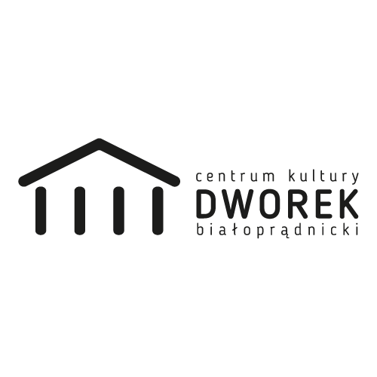

FOTO

Name and current address of the volunteer
Family name |  | First name
Street address
Postcode |  | City
Region |  | Country
Telephone |  | Email

Personal details
Date of birth |  | Gender |  | female | male
Place of birth |  | Nationality
Highest level of education (1 box only) | primary education |  | vocational training
 | secondary education |  | higher education
Current situation  (1 box only) | working |  | studying
 | unemployed |  | training
 | long-term unemployed (> 6 months) |  | other

Emergency contact (name address, telephone):

- Describe briefly your current situation (work, school, family): are you studying, working or doing something else? How will you combine this with your ESC? Do you have to leave school/job for your ESC project?

- Please describe briefly your best work experience.

- Have you ever participated in any of European Programme (Erasmus, Leonardo, Socrates, Youth) or do you have already some international experiences such as travels?

- What are your language abilities?
Level of English fluent good basic none
level of Polish fluent good basic none
level of.......... fluent good basic none
- What do you find interesting in this project? How do you imagine the work to be and how would you like to contribute?

- Do you have any artistic skills? (for example playing instruments or visual arts skills) What kind?

- Can you organize your work, and organize the events that would be given to you? Give an example of a time you used your organizational skills to organize and event or activity.

- What are your expectations, fears and needs for your ESC project?

- Have you ever been living alone? Where and how long?

- Have you ever been living abroad? Where and how long?

- Do you have any special needs (dietary needs, health care)?

- Do you have any health problems that we have to know about? This is really important. You can be sure that this information will remain confidential.

- Do you think you can have problem in sharing an apartment or a room with others people?

- Would you describe yourself as self-reliant? Please tell us why?

- Why did you choose Poland for your ESC project?

- Which of the hosting organizations you would like to volunteer in the most and why?
- Cultural Center Dworek Białoprądnicki
- Cultural Club Przegorzaly
- Cultural Club Wola
- Cultural Club Łokietek
- Cultural Club Mydlniki
- High School XXVII

Please fill if you have supporting organization.

TO BE COMPLETED BY THE SENDING ORGANIZATION
Sending Organisation:
Phone:
Fax:
Email :
Address:
Code PIC
The sending organisation accreditation (EI) number:
Contact Person:

- How did you select the volunteer?

- What kind of preparation will you provide the volunteer with?

- How do you organise the pre-departure training for the volunteers?

