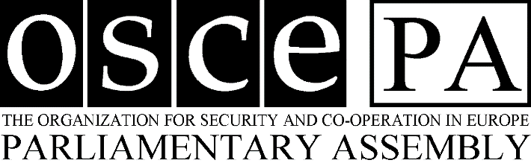

Photograph

INTERNATIONAL RESEARCH ASSISTANT PROGRAMME
Please attach a short cover letter, a detailed CV, a transcript of grades, two letters of recommendation,
and complete the attached form in English.

Please write clearly

1. Name:
2. Address:

3. Telephone number:
4. E-mail address:
5. Mother tongue:
6. Citizenship:
7. Sex:……………………… Marital status:
8. Date of birth: …………………… Place:

Education (Please write further details in your CV)
9. Undergraduate University or College:

10. Graduate University or College:

Field of studies:
Year of graduation:

11. Other university level courses relevant to the OSCE PA:
(e.g. courses in public relations or communication)

Languages
 | English | French | German | Italian | Russian | Spanish
Excellentª
Working knowledge^{b}
Limited knowledge^{c}
Minimum knowledge^{d}
(Please indicate: W = Written, S = Spoken)

ªExcellent knowledge: equivalent to mother tongue
^{b}Working knowledge: fluency in the language. Ability to work independently in the language required, to prepare written communications and to participate actively in meetings and work related discussions.
^{c}Limited knowledge: good knowledge of the language. Ability to follow work related discussions or meetings, to participate in simple conversations, to read and understand work related texts and to write simple communications.
^{d}Minimum knowledge: fair or slight knowledge of the language. Ability to understand simple conversations and written texts.

12. Other languages:

13. Language courses attended:

Work experiences and skills
14. Past work experience:

Computer skills
15. Word processing programmes:
16. Database programmes:
17. Internet/communications:
18. Desktop Publishing:
Other questions
19. Why are you applying for a Research Assistantship?

20. Hobbies and other interests:

21. References:
A)
B)

I certify that the statements made by me in the application form are true and correct to the best of my knowledge and belief.

Date: Signature:

